

**Networking Principles, Protocols and Devices**

Unit 2: Networking



Zwe Hset Naing

HND 29th Batch

Youth International University

Contents

No table of contents entries found.

# Design of a networked system to meet a given specification

## Network Diagram

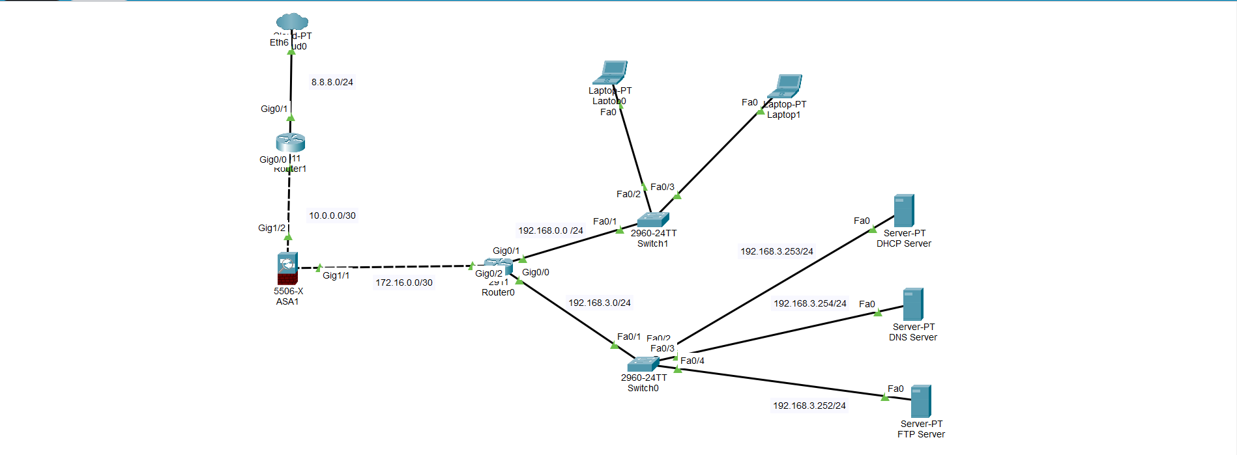

## Internet

In this Diagram, I use Network to improve the model's capacity to identify complex representations and patterns in the data.

## DHCP Server

In network systems, the assignment and administration of IP addresses and other network configuration settings for devices on a network are automated through the use of DHCP (Dynamic Host Configuration Protocol) servers.

## DNS Server

In order to enable users to access websites and other resources using easily remembered names rather than numerical IP addresses, a DNS (Domain Name System) server is an essential part of network systems. It transforms human-readable domain names into IP addresses.

## File Sharing Service (FTP)

In network systems, an FTP (File Transfer Protocol) server is used to make file transfers between devices over a network easier.

# A maintenance schedule to support the networked system

To maintain the efficiency and reliability of the interconnected infrastructures is managed by network system. Network system is an important role in collaboration, data transfer and connection. The following schedule is used to enhance the network’s system maintaining.

|  |  |  |  |  |
| --- | --- | --- | --- | --- |
| Name | Daily | Weekly | Monthly | Yearly |
| Updates (New Package and Other Applications) |  |  |  |  |
| Security (Server and Firewall) |  |  |  |  |
| Data Backup |  |  |  |  |
| Performance Monitoring |  |  |  |  |
| Network Device Replacement Planning |  |  |  |  |
| Troubleshooting and Issue Resolution |  |  |  |  |

# Implementation of a networked system based on a prepared

# Design

## Implementation

Implementation includes installation and configuration steps. These steps are implemented DNS server in visual machine.

## Installation

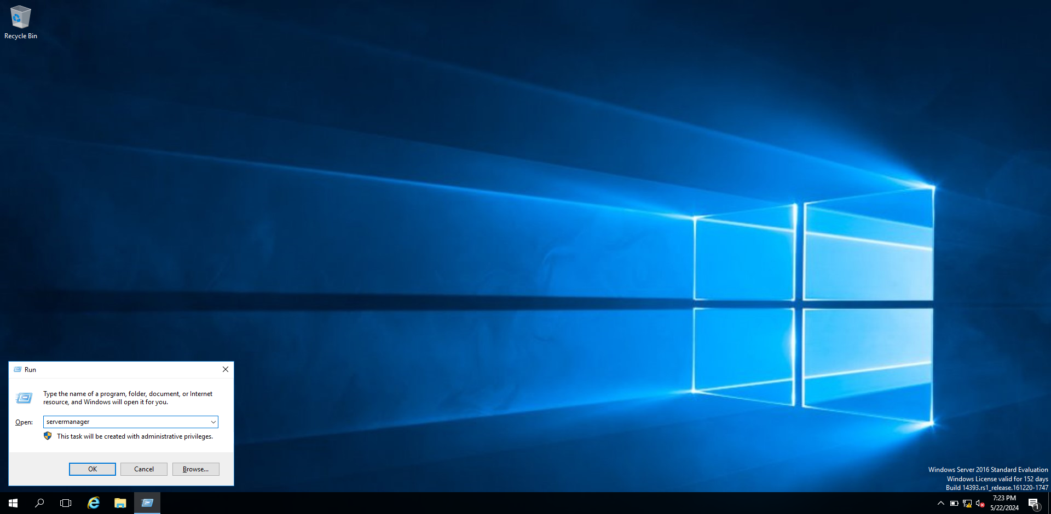

Use window+r to open run box. And then write command “servermanager” to open Server Manager.

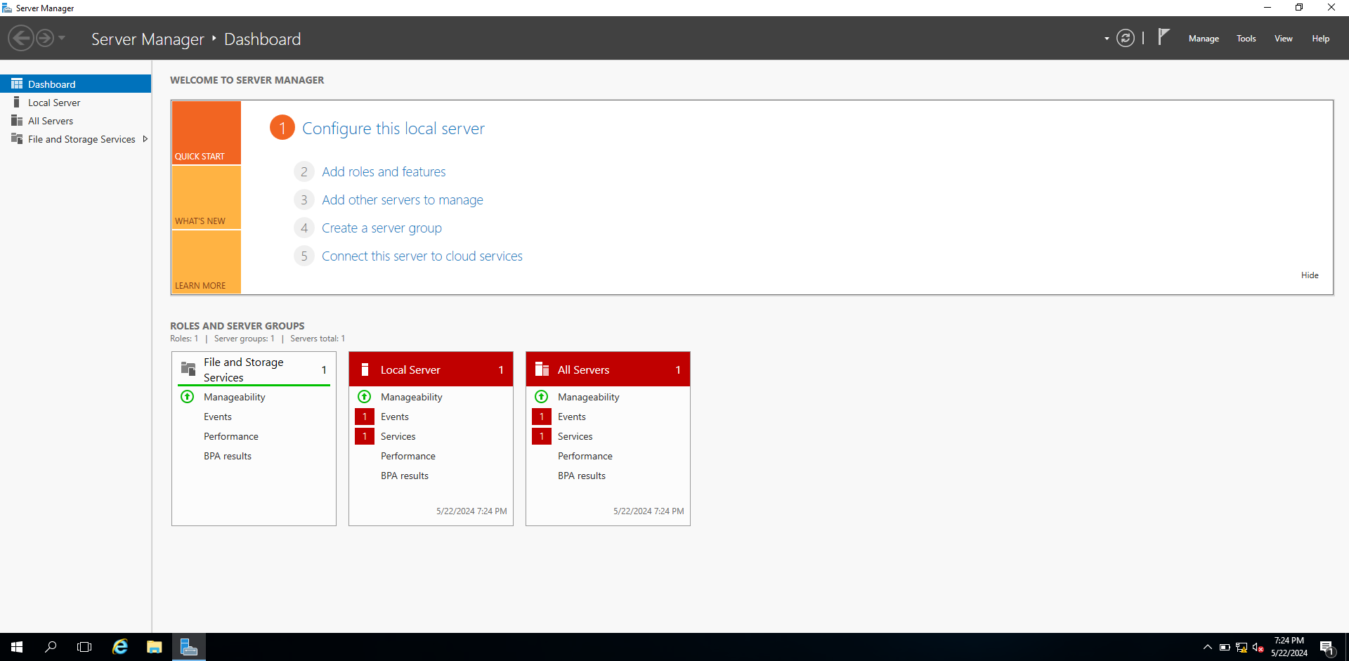

When writing the command, server manager will open.

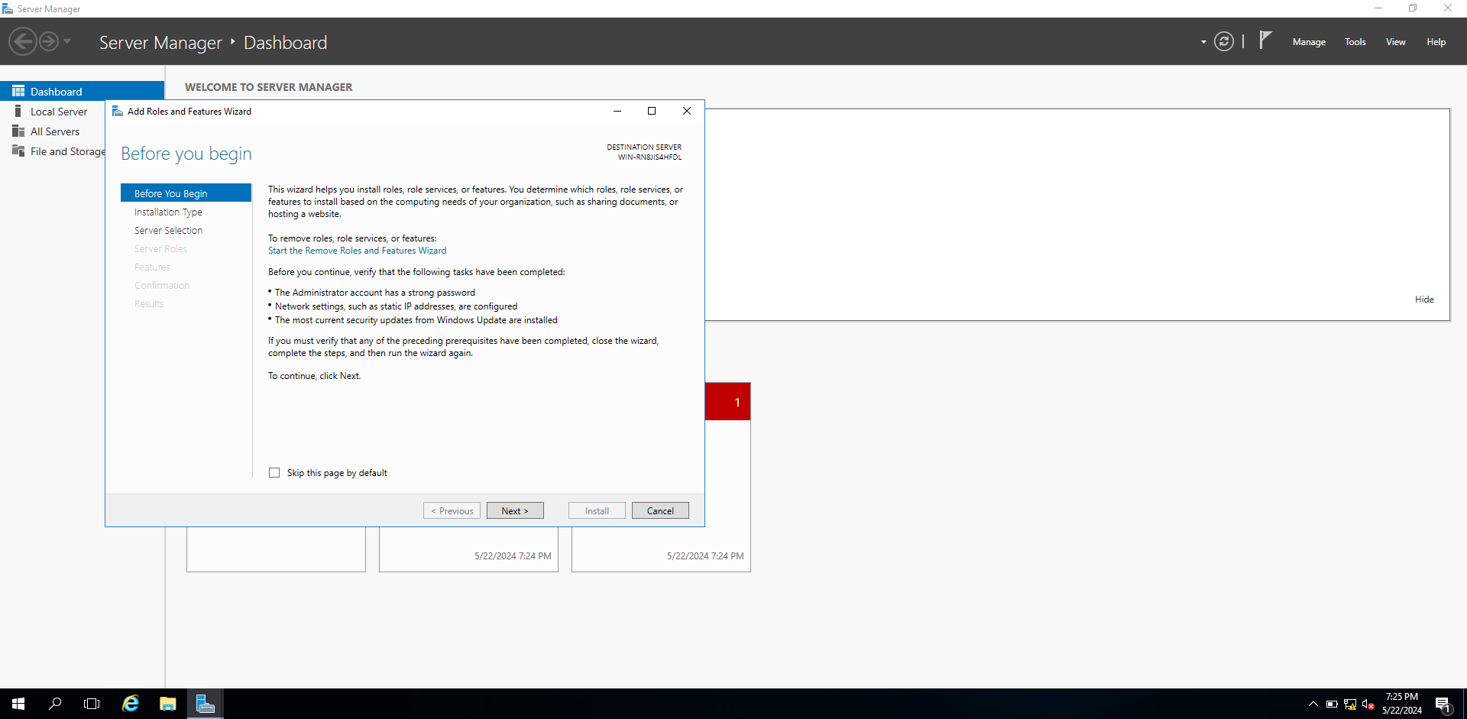

Tap manage and choose add roles and features. When it is finished, add roles and features Wizard will open.

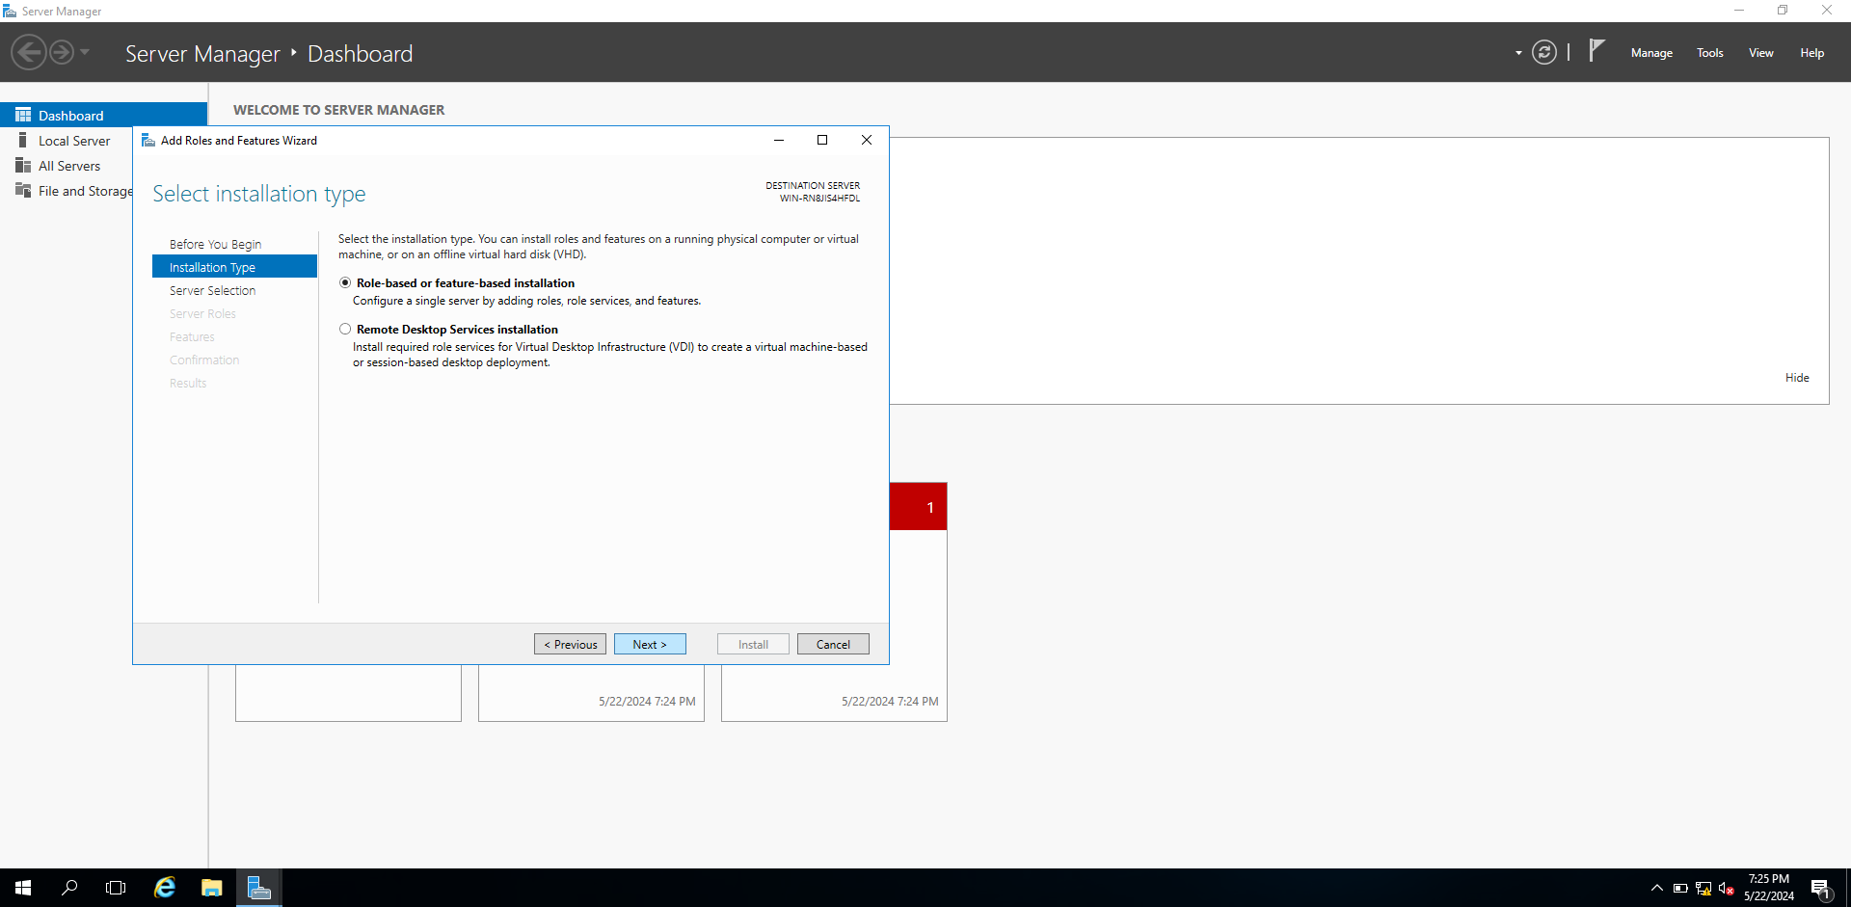

When tapping the next, it will arrive to next page.

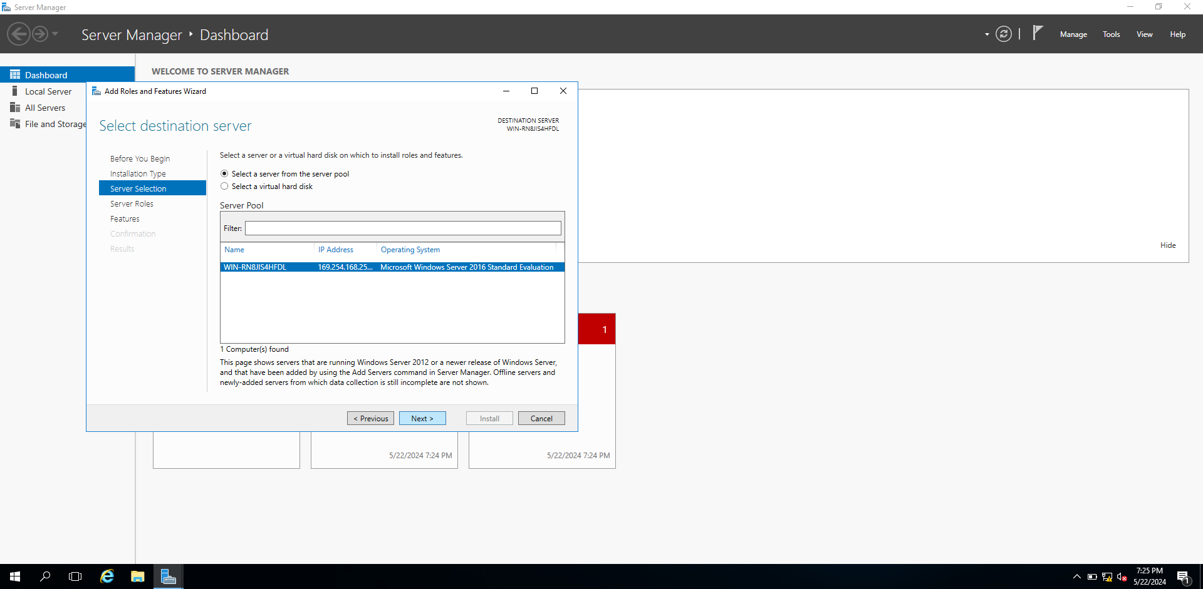

When tapping the next, it will arrive to next page.

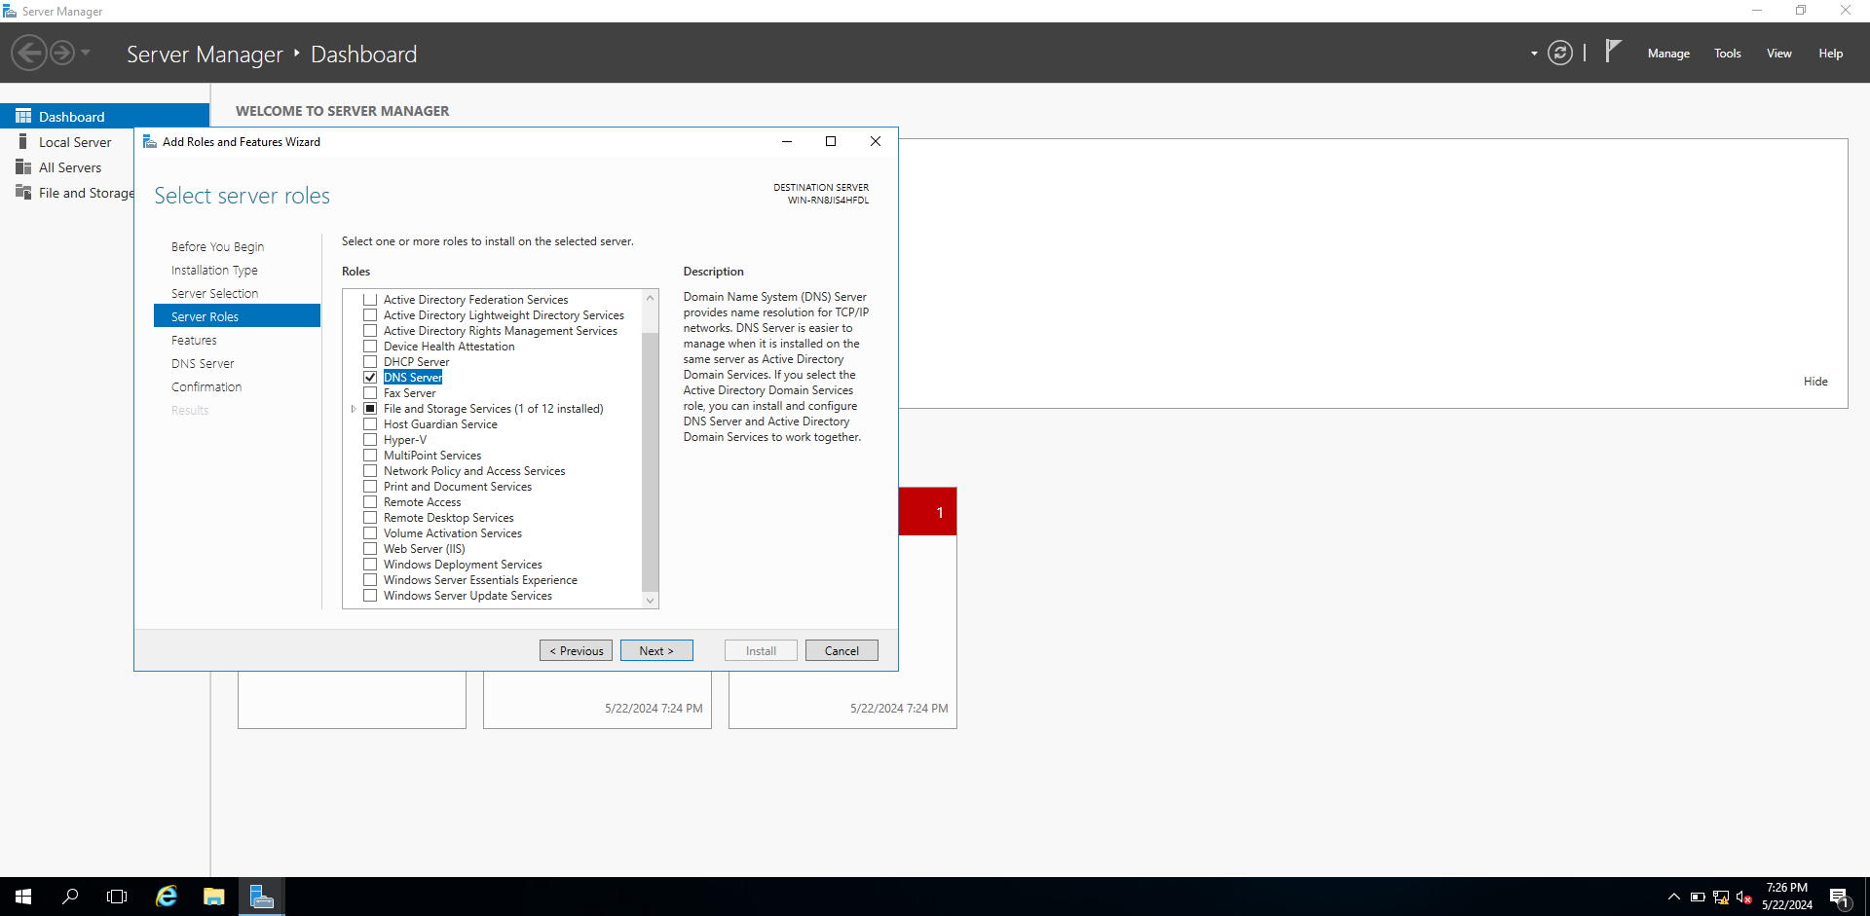

When tapping the next, it will arrive to next page. And then choose DNS server.

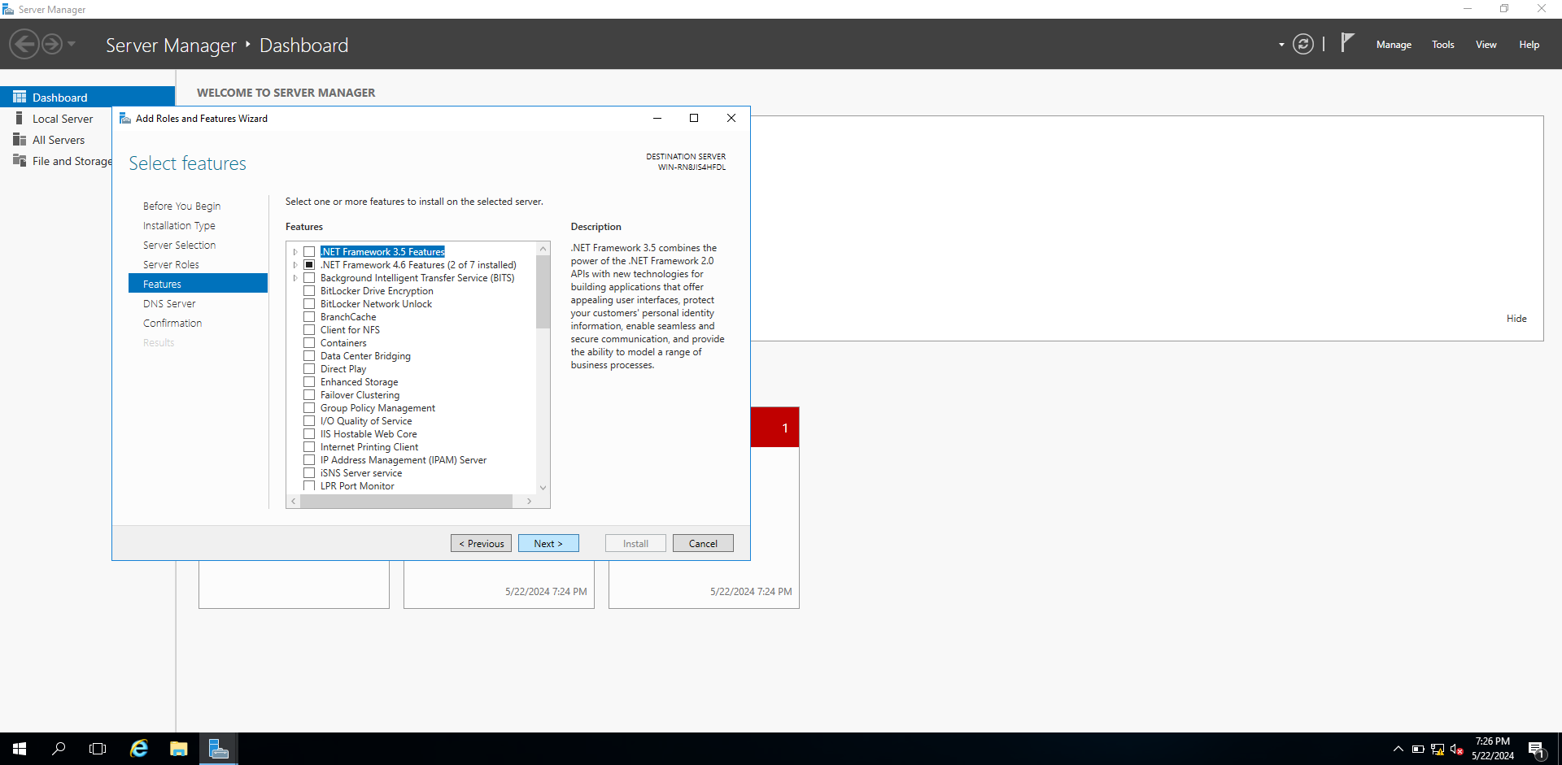

When tapping the next, it will arrive to next page.

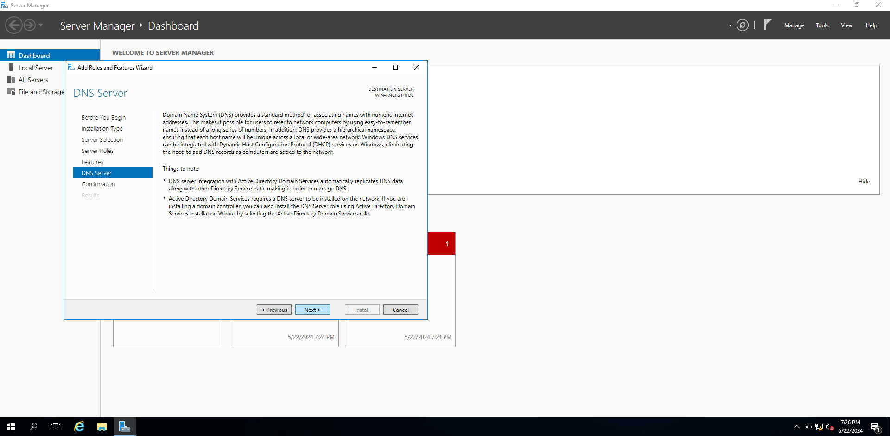

When tapping the next, it will arrive to next page.

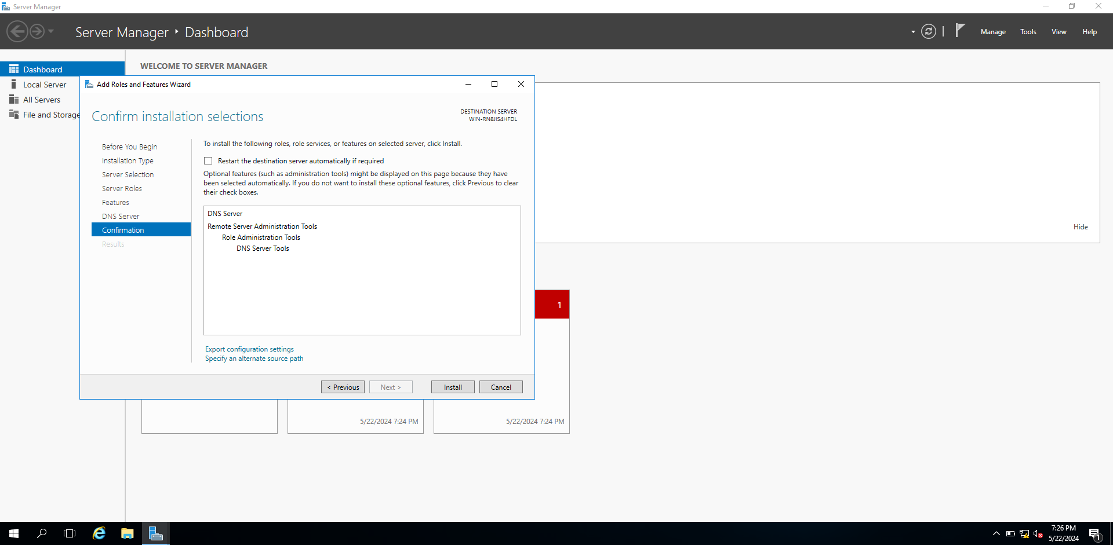

When tapping the next, it will arrive to next page.

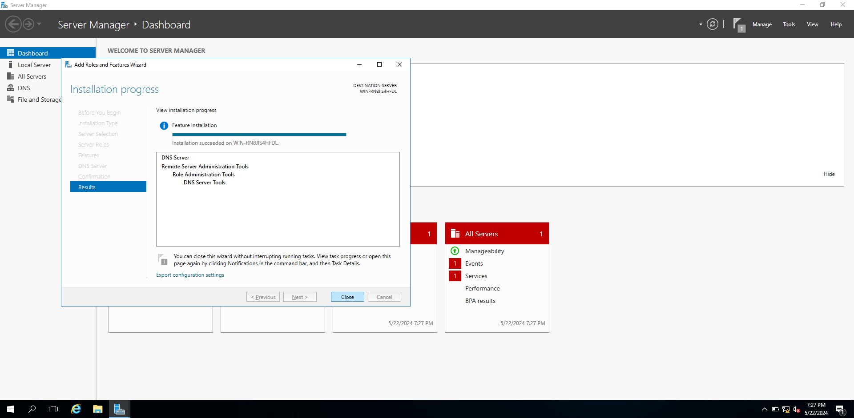

When tapping the next, it will arrive to next page.

## Configuration

# 

Use window+r to open run box. And then write command “ncpa.cpl” to open network connections.

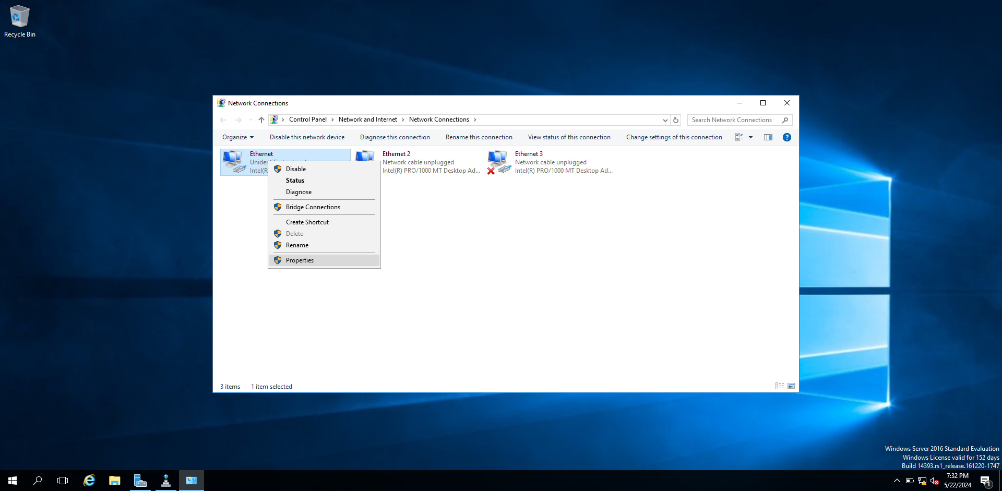

When using command, this step will arrive.

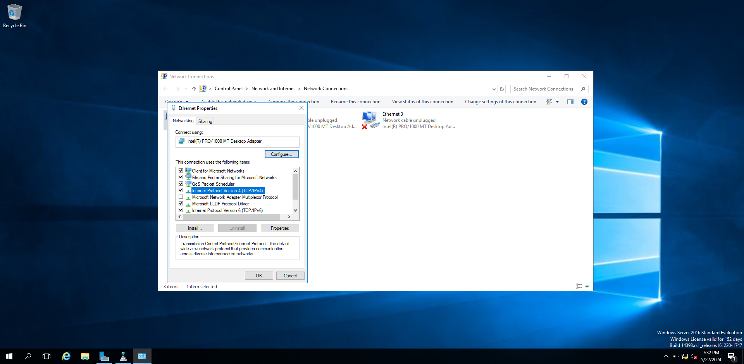

And then tap right click and choose properties.

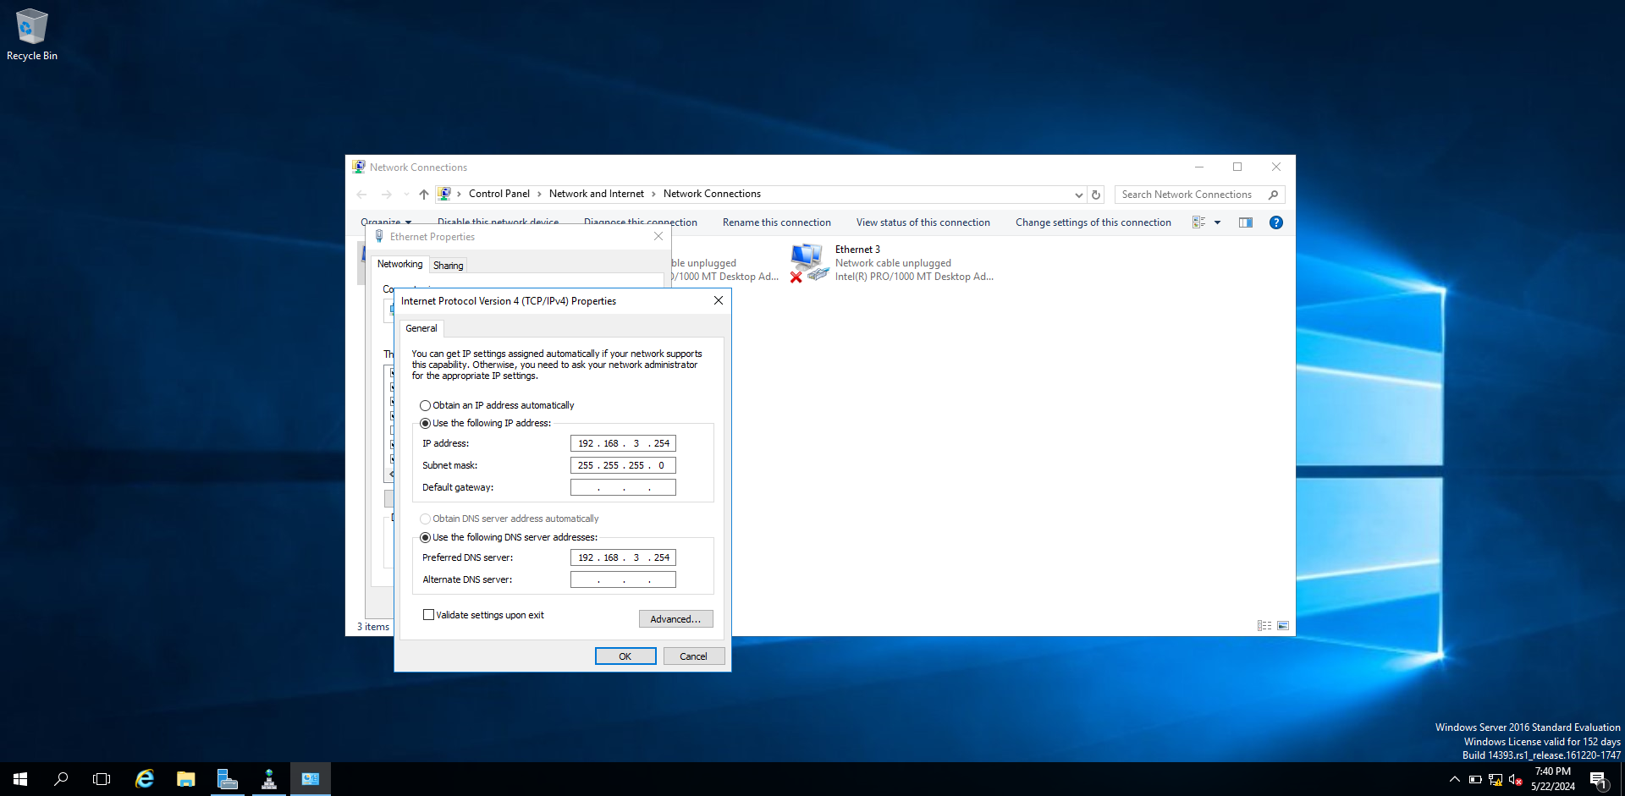

And then tap the Ipv4 and give ip address and dns server.

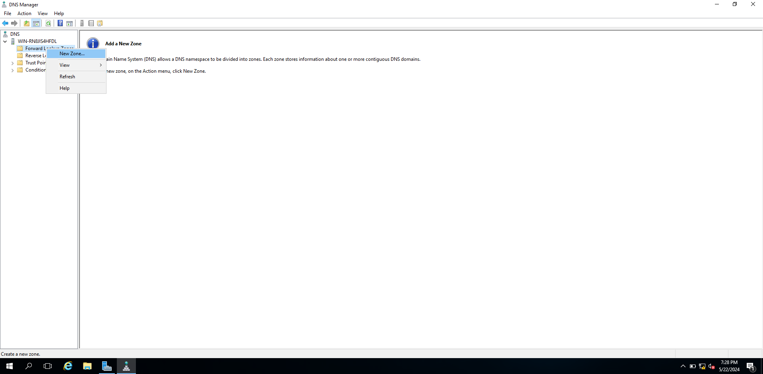

When we installed the dns server, this page will open. And then tap right-click to the forward lookup zone and choose new zone.

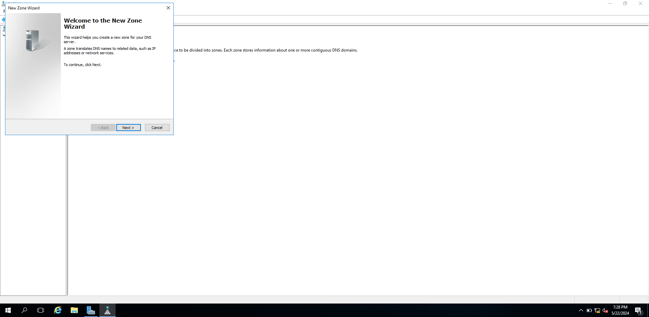

When tapping the next, it will arrive to next page.

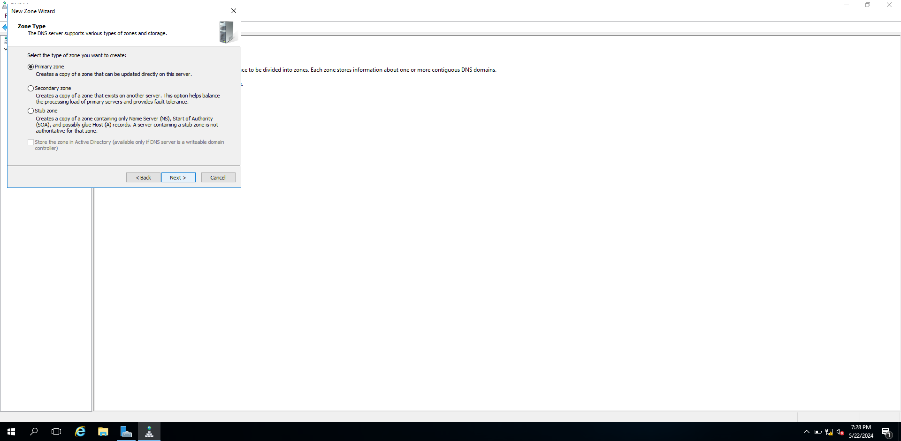

When tapping the next, it will arrive to next page.

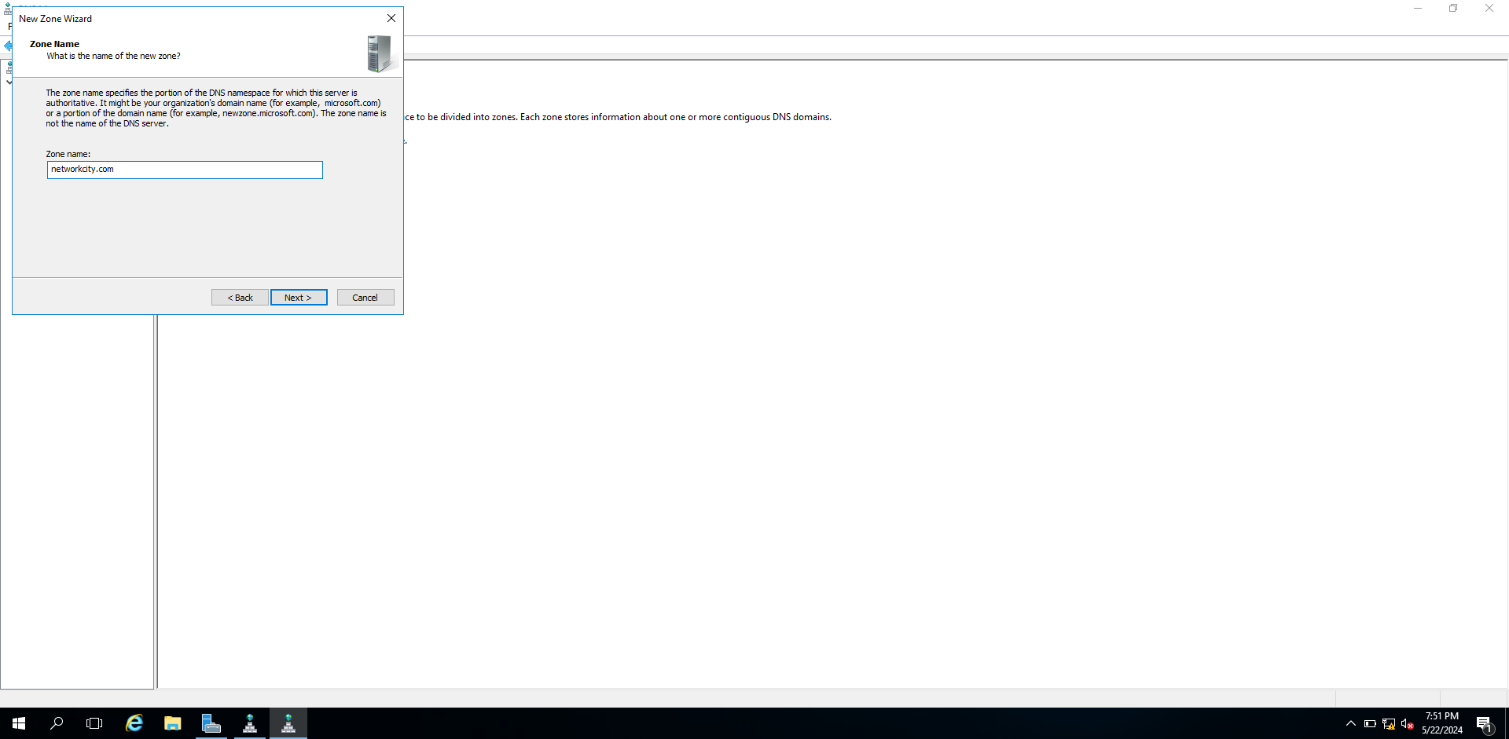

Write the zone name “network.com”. When tapping the next, it will arrive to next page.

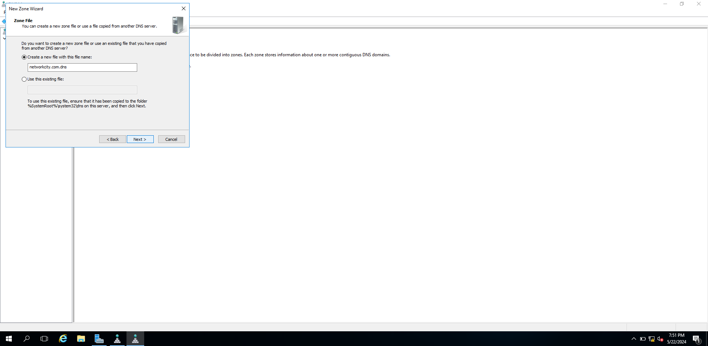

When tapping the next, it will arrive to next page.

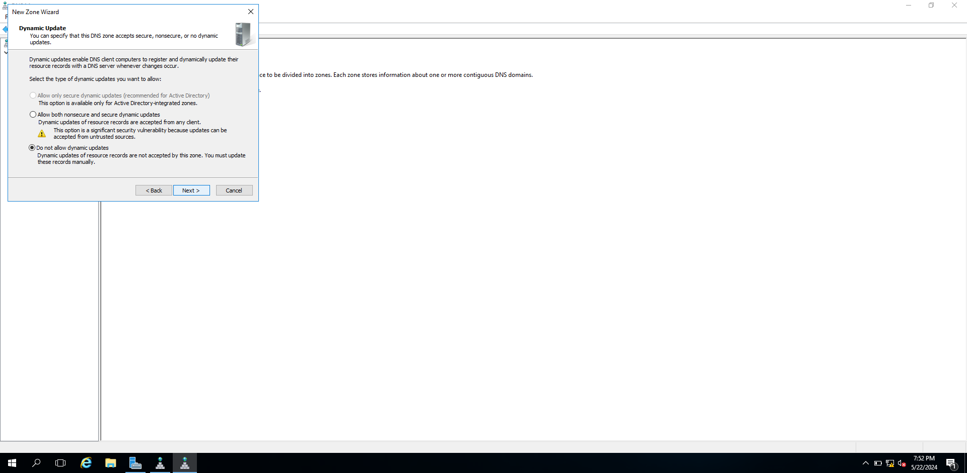

When tapping the next, it will arrive to next page.

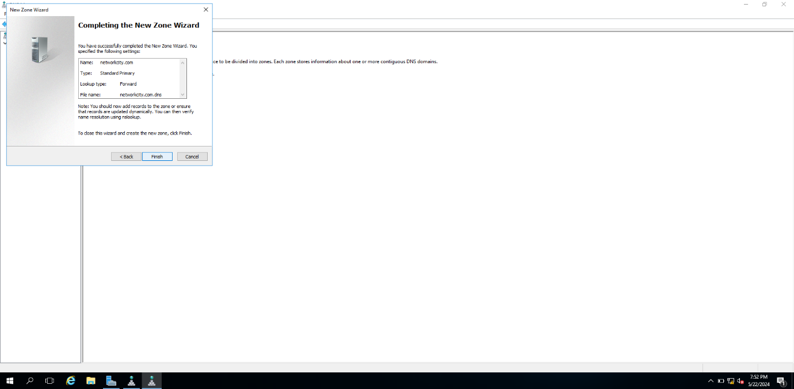

When tapping the finish, it will finish.

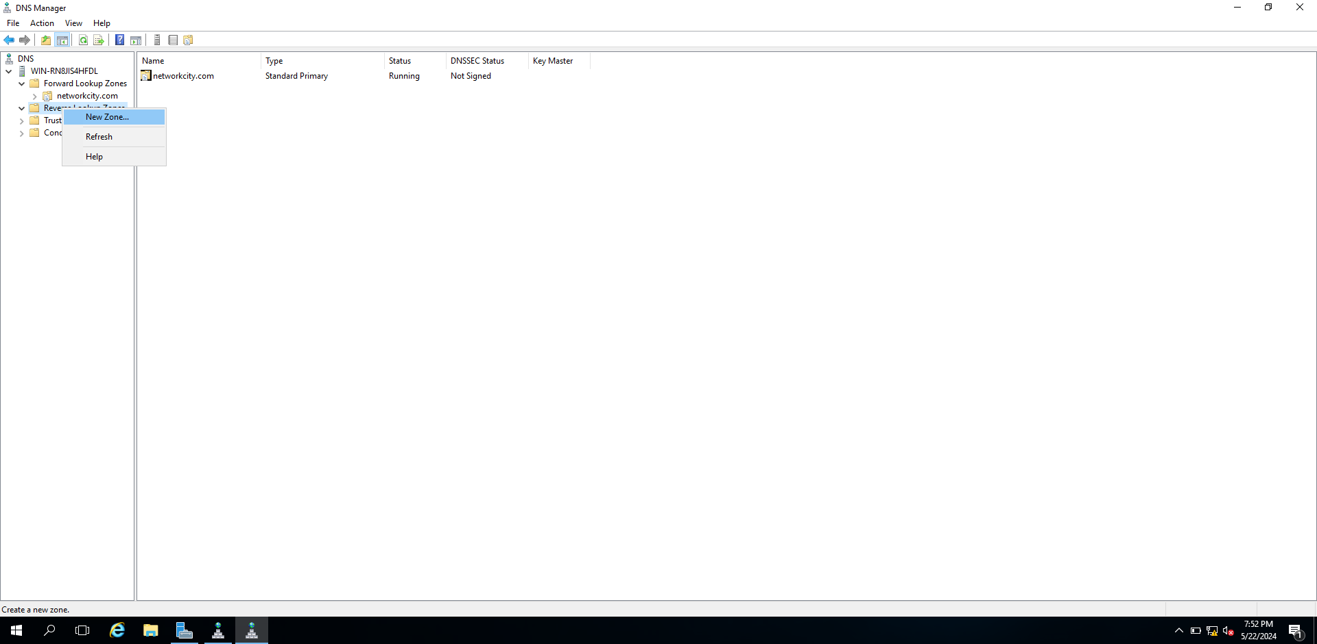

And then tap right-click to the reverse lookup zone and choose new zone.

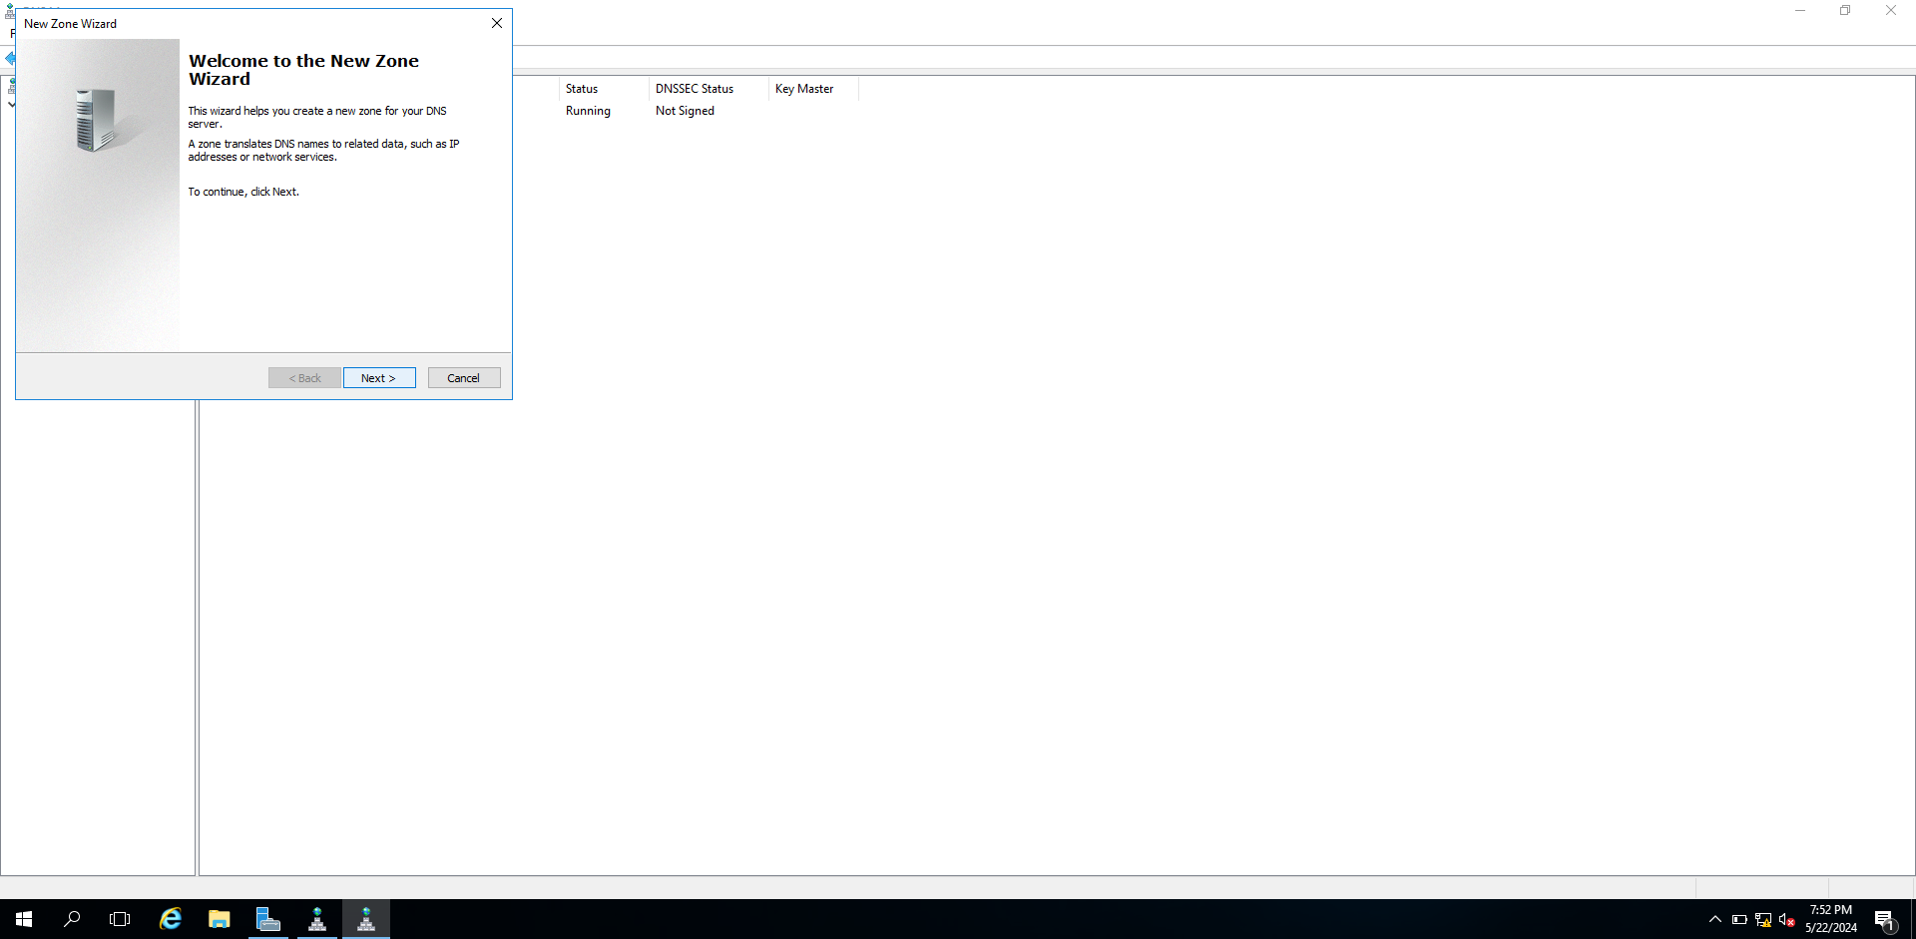

When tapping the next, it will arrive to next page.

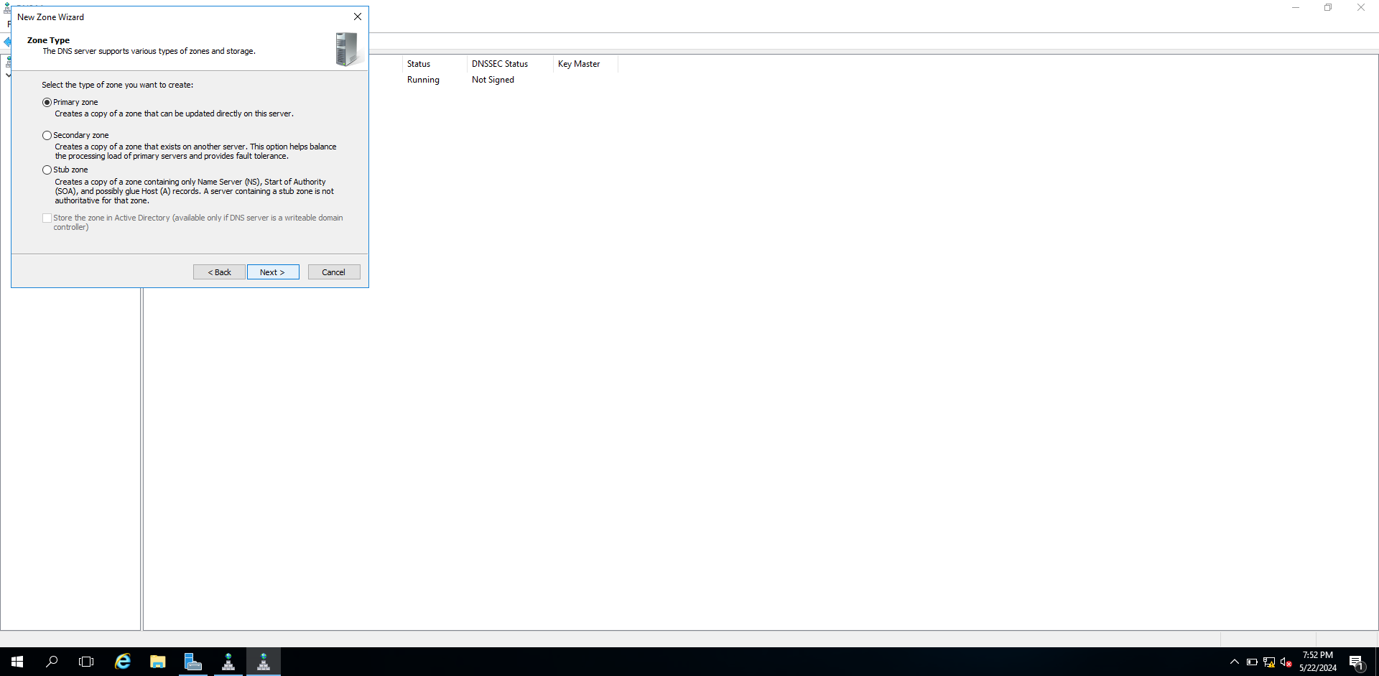

When tapping the next, it will arrive to next page.

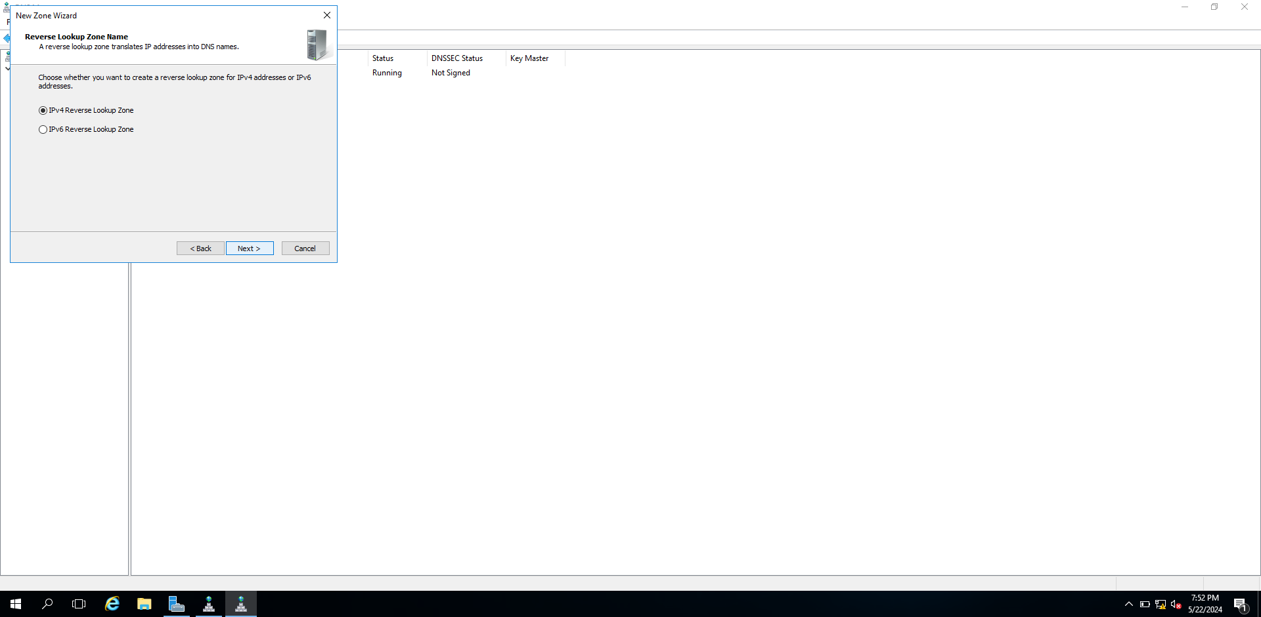

Choose the Ipv4.When tapping the next, it will arrive to next page.

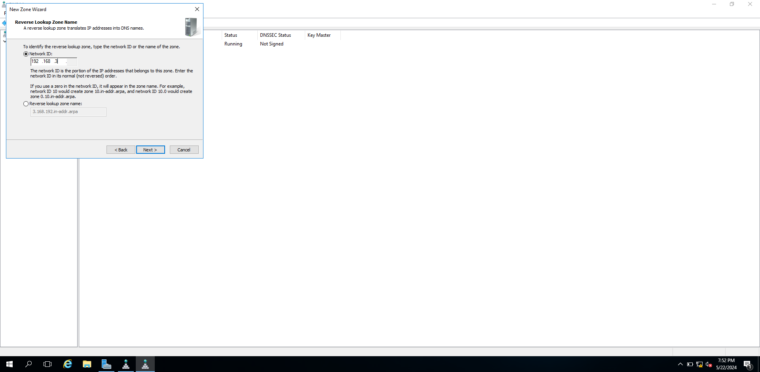

Write the network number “192.168.3”. When tapping the next, it will arrive to next page.

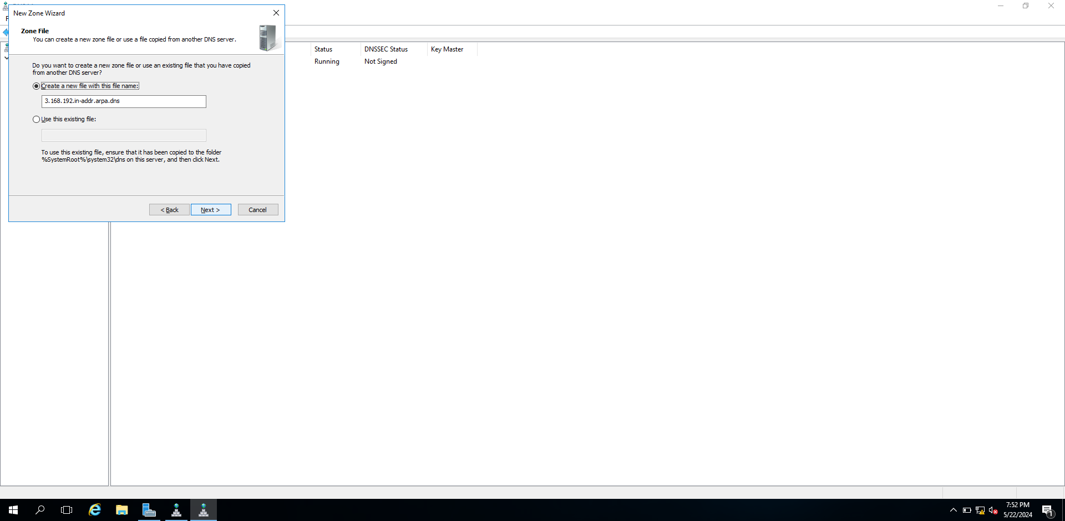

When tapping the next, it will arrive to next page.

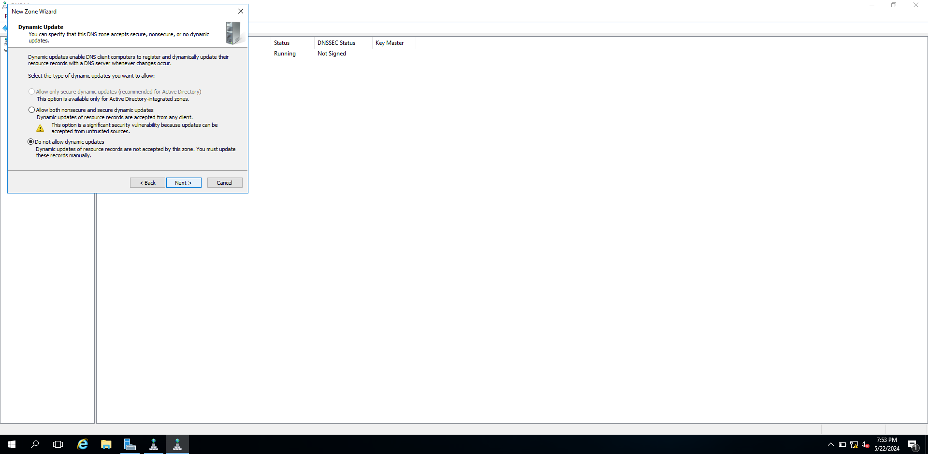

When tapping the next, it will arrive to next page.

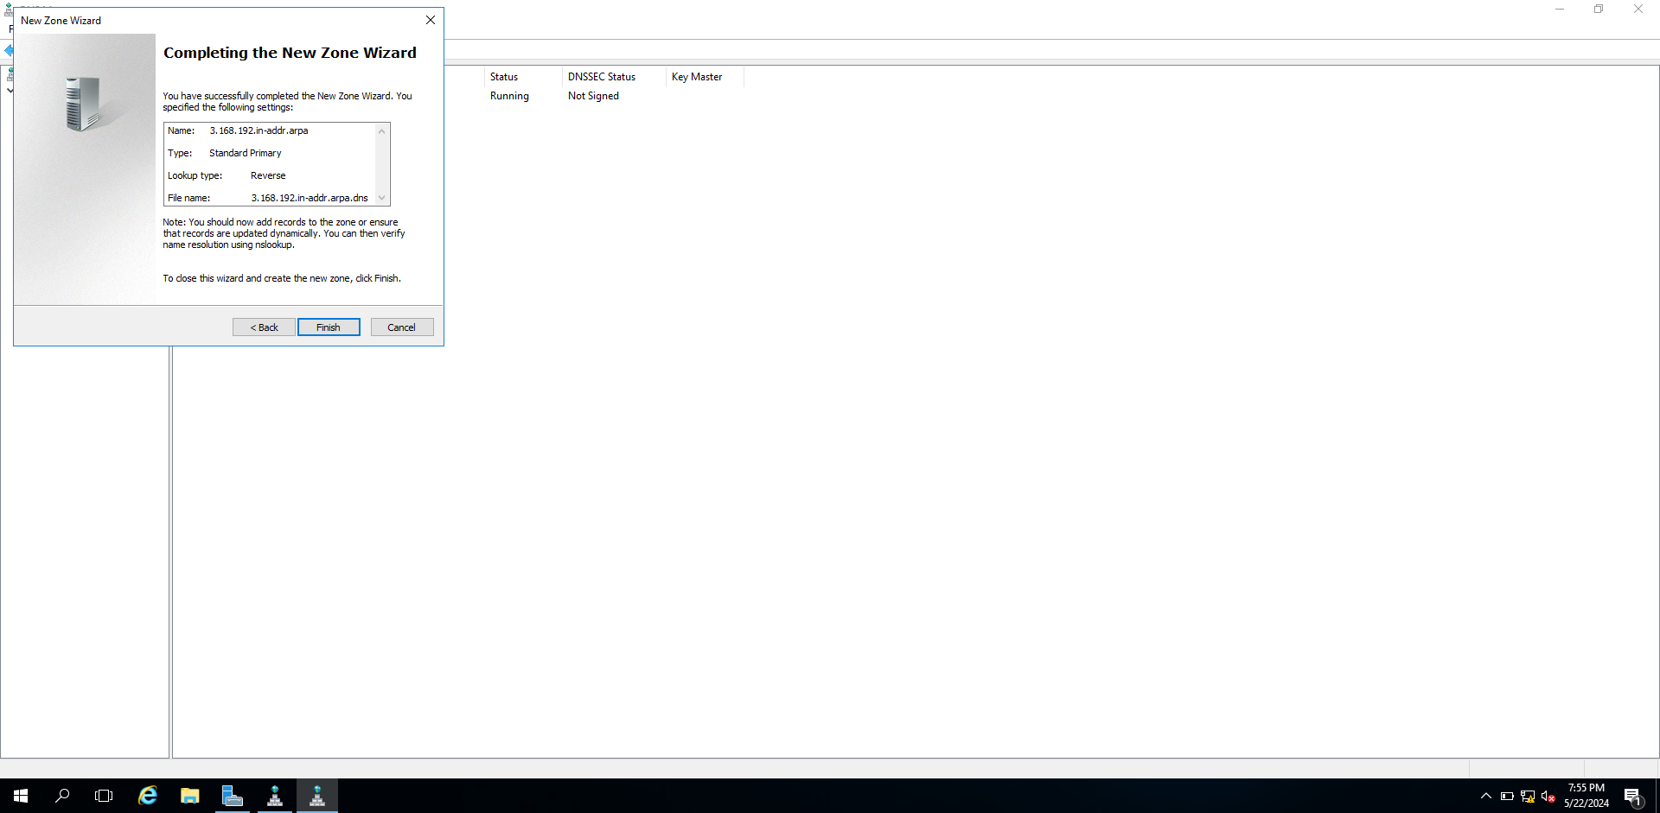

When tapping the finish, it will finish.

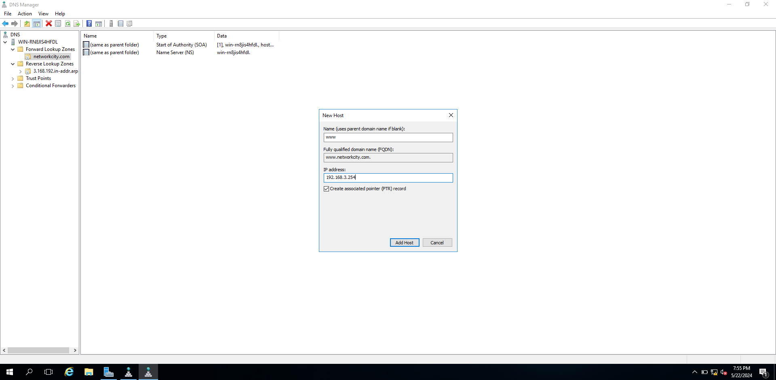

Fill “www” at Name, “[www.networkcity.com](http://www.networkcity.com)”at fully qualified domain name and “192.168.3.254” at IP address. Tip the mark at the box and tap the add host.

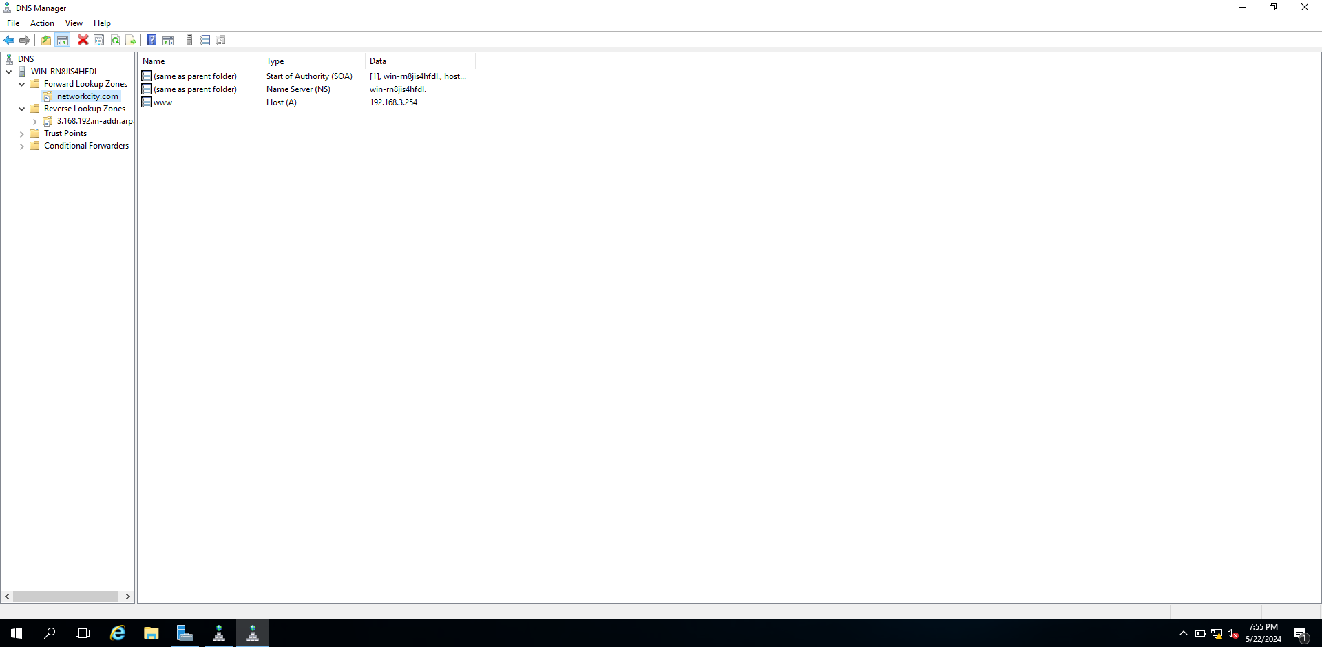

This step will show the host and configuration will finish.Documentation and analysis test results against expected results

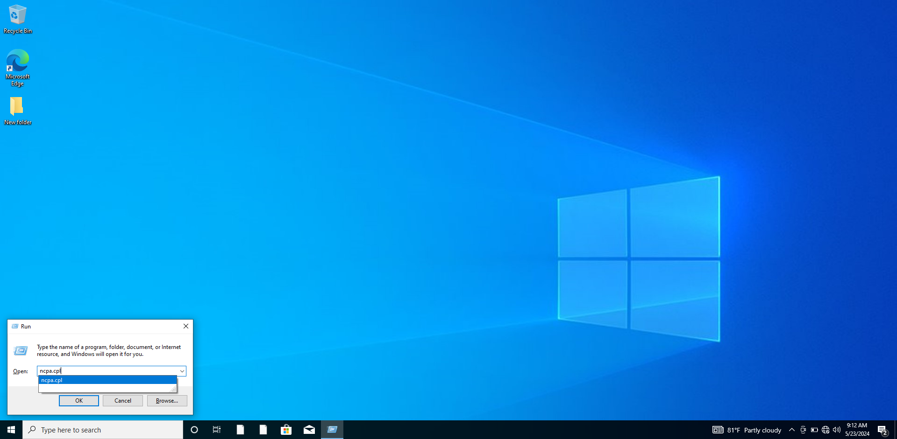

Use window+r to open run box. And then write command “ncpa.cpl” to open network connections.

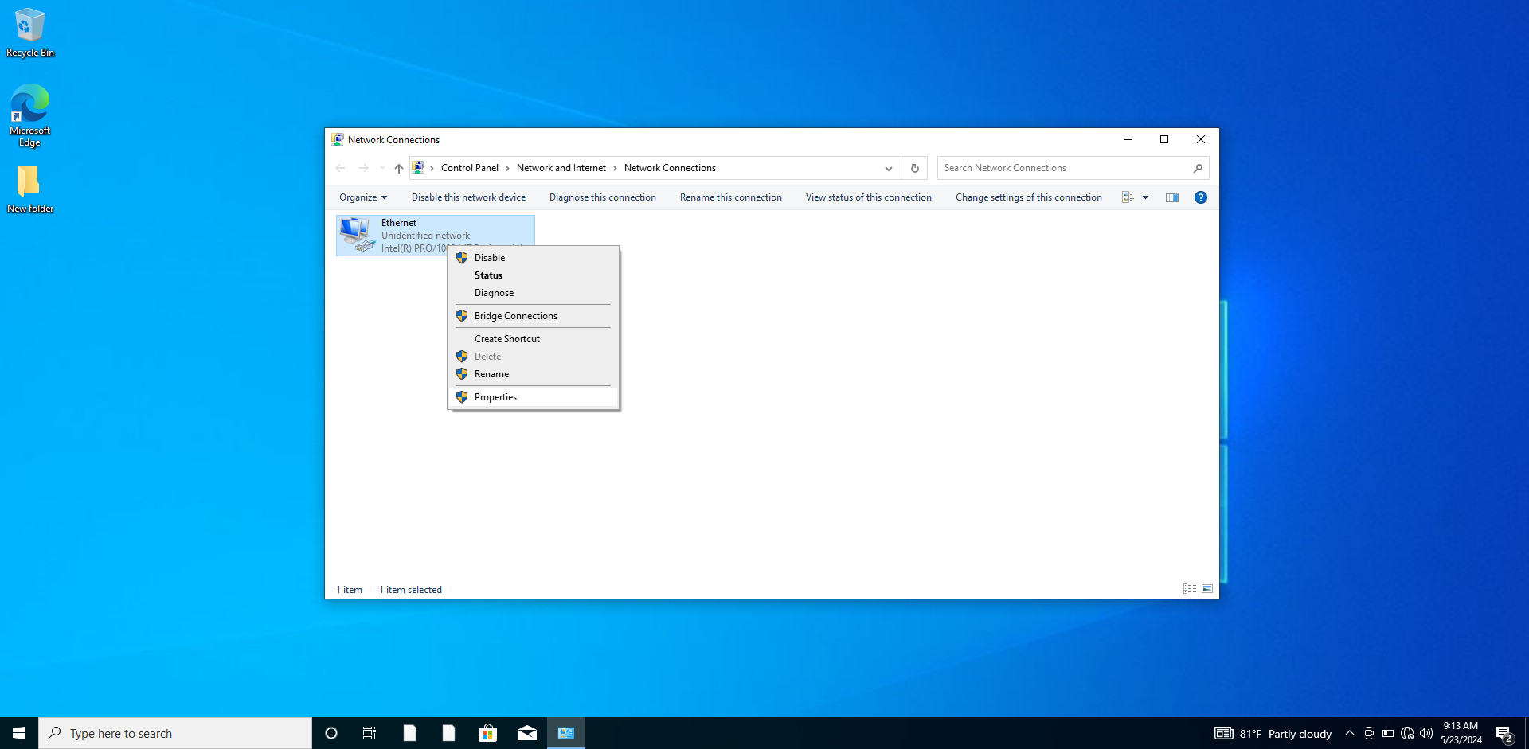

When using command, this step will arrive.

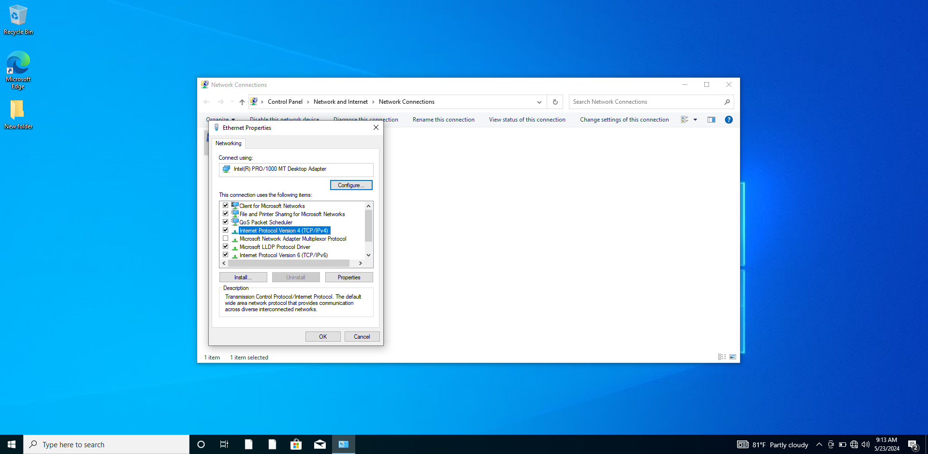

And then tap right click and choose properties.

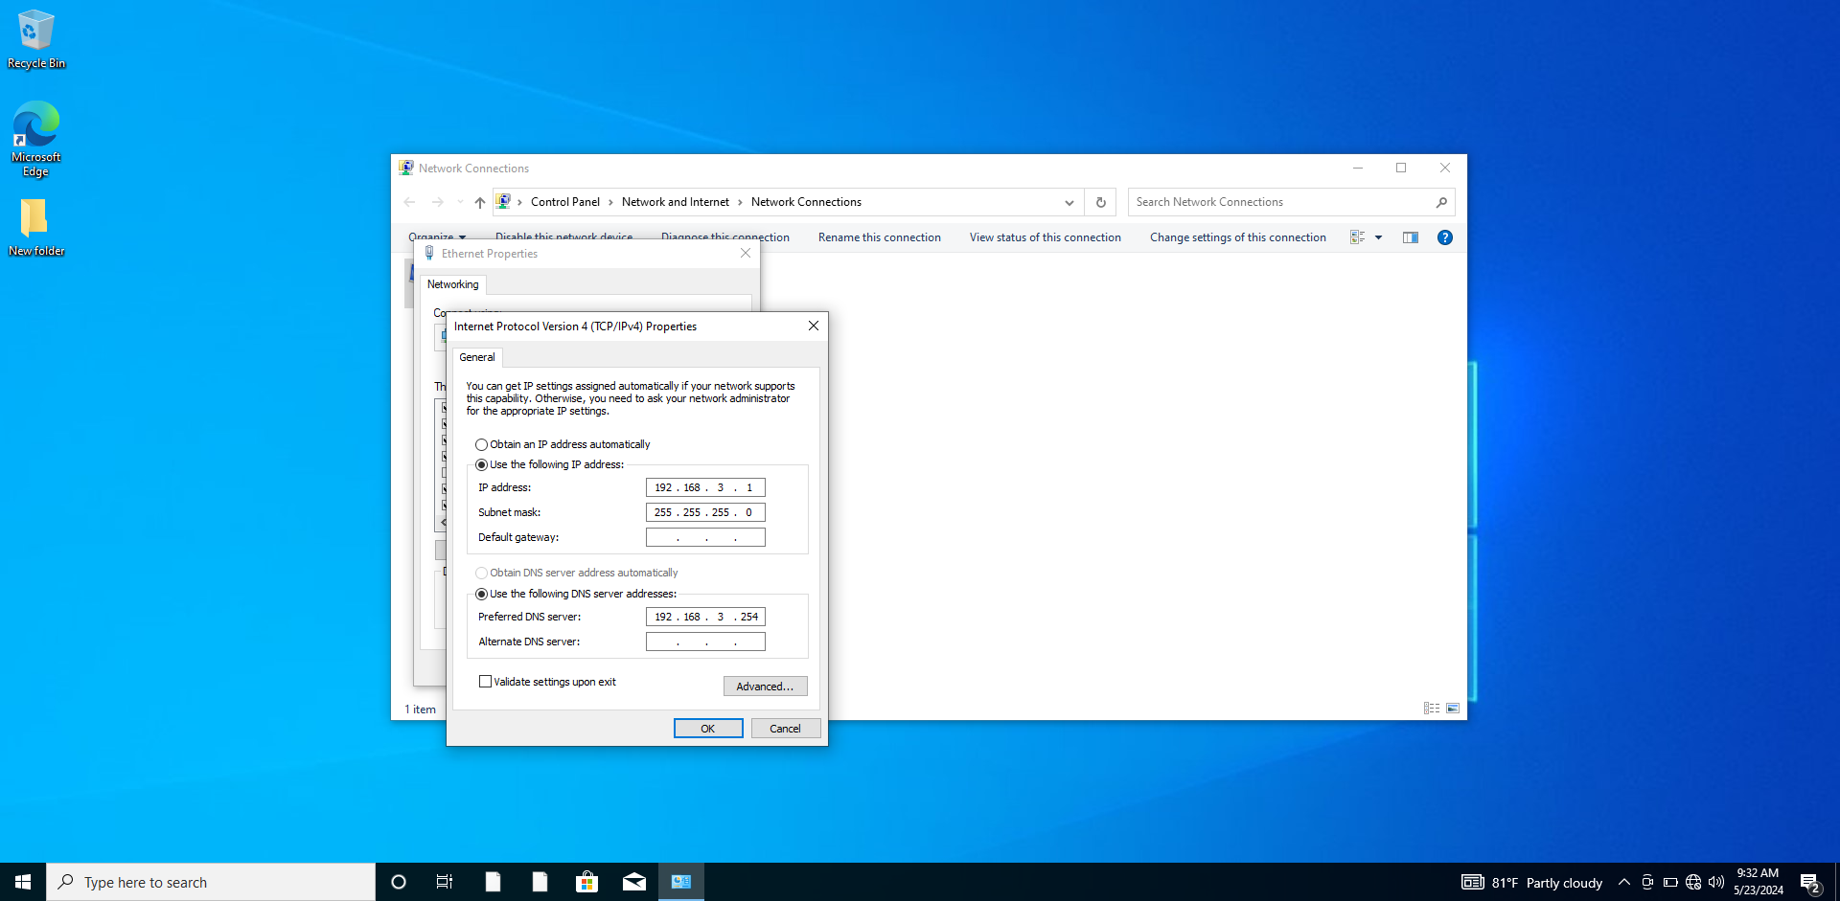

And then tap the Ipv4 and give ip address and dns server.

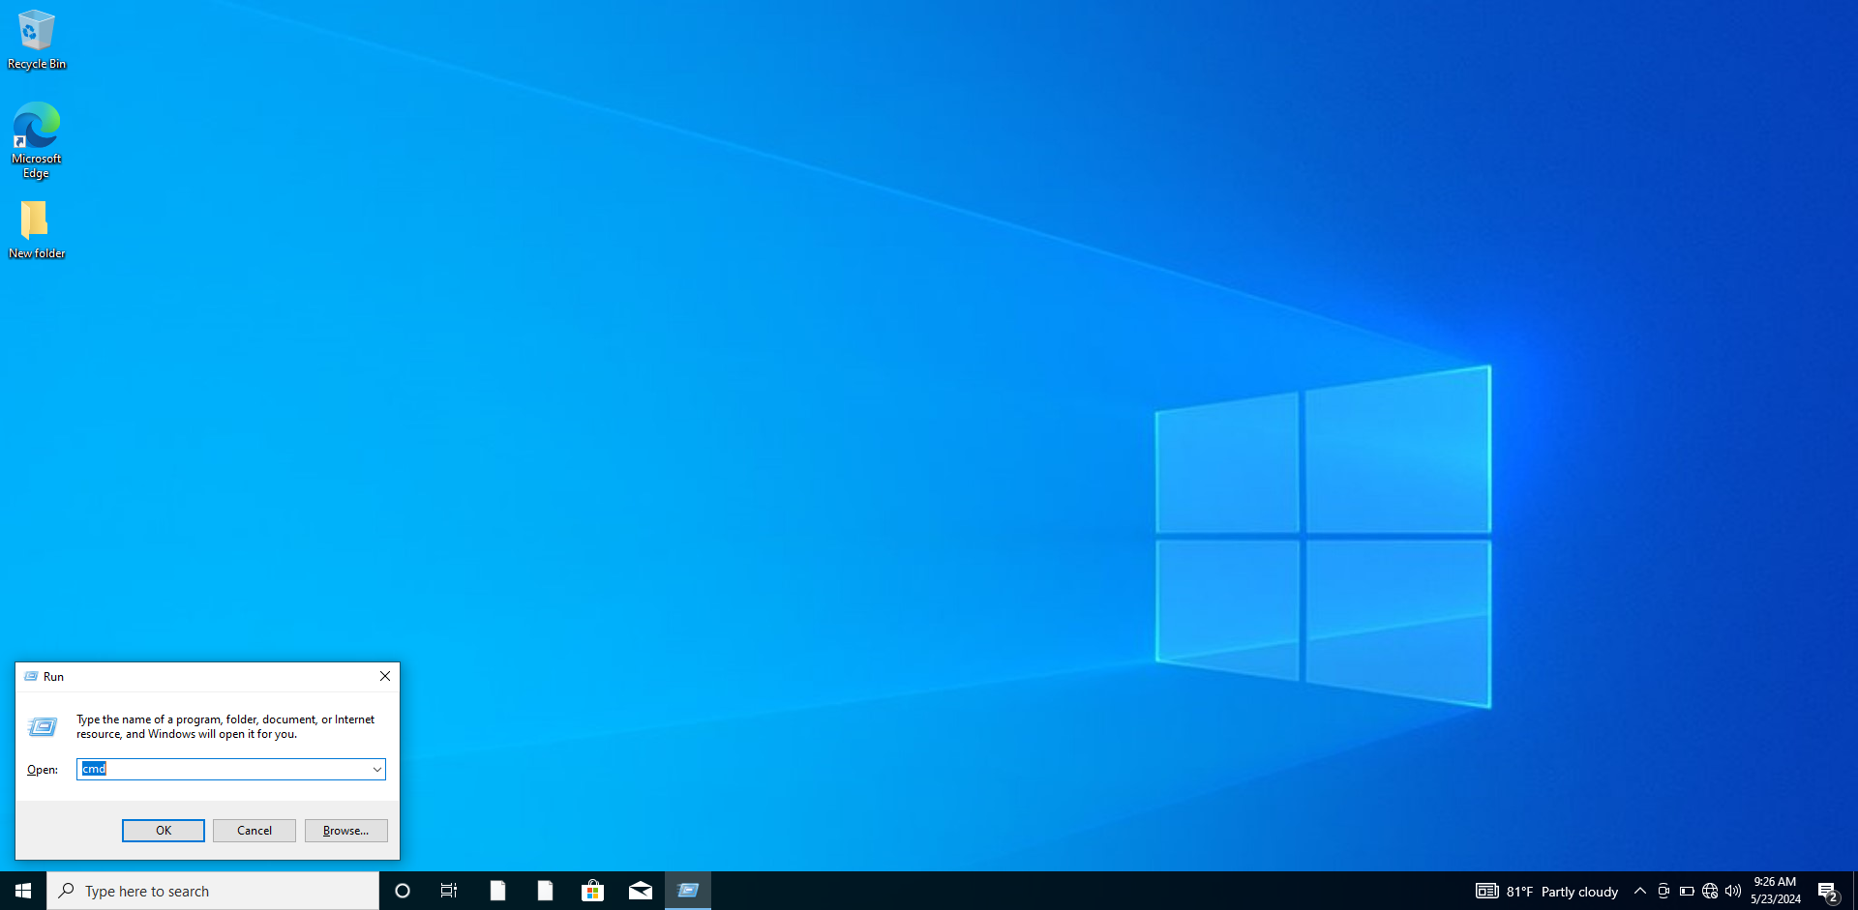

Use window+r to open run box. And then write command “cmd” to open command prompt.

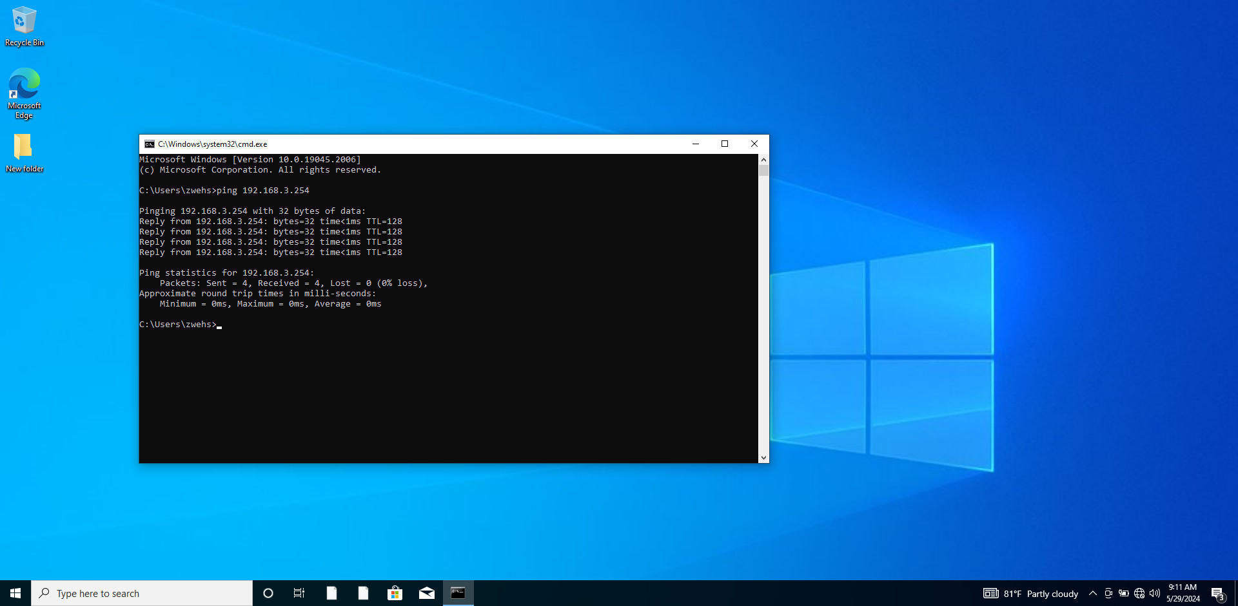

When the command prompt open, write “ping 192.168.3.254” to check the connection between pc and server. If it reply back, the connection will perfect.



Use window+r to open run box. And then write command “cmd” to open command prompt.

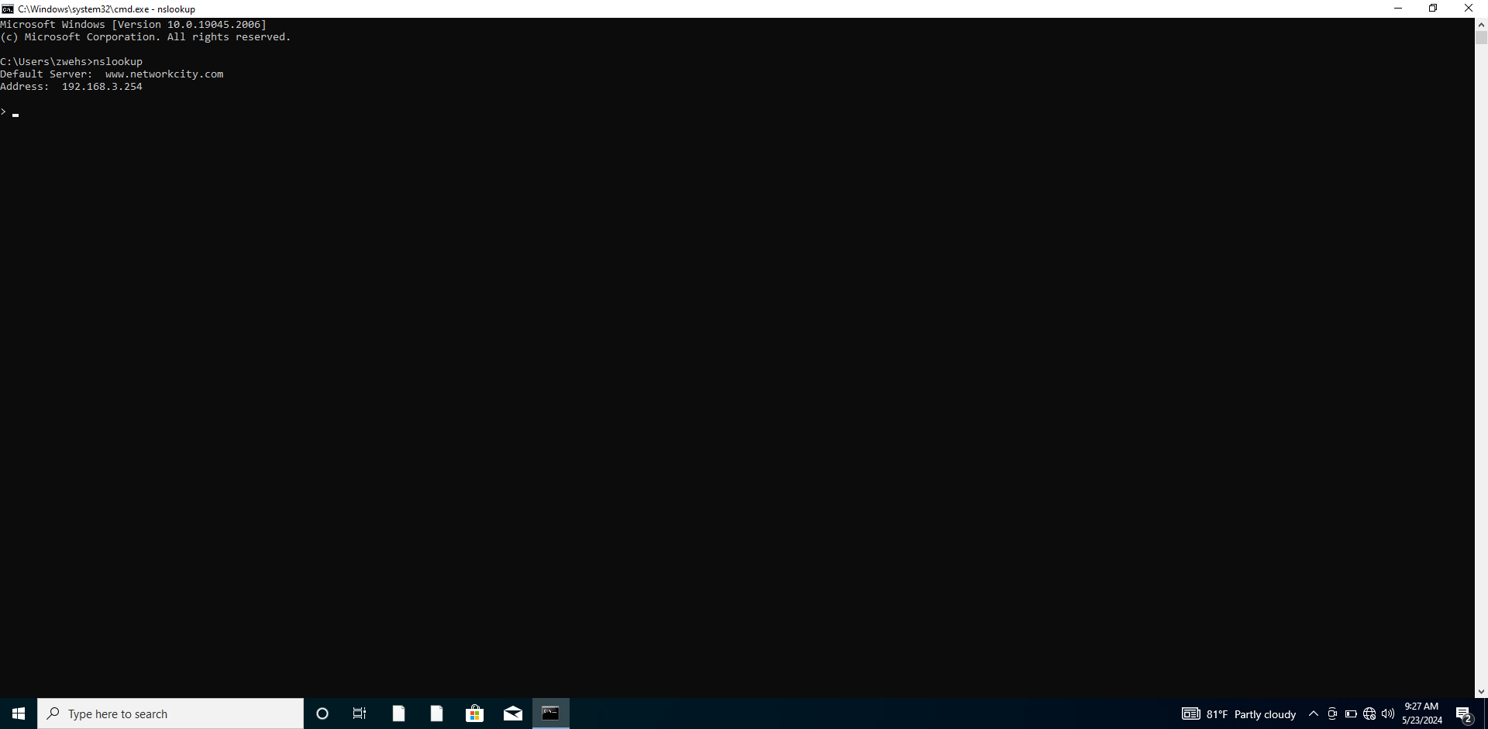

When the command prompt open, write “ns lookup” to check the dns server. If it replies the network name and ip, the process is done.

References